User

user_id  int

name varchar

email varchar

phone varchar

password_hash varchar

role varchar

Booking

 | PhotographerProfile
0..1 0..1 | photographer_id | _{int} 0..1
* | user_id | int
 | bio | varchar
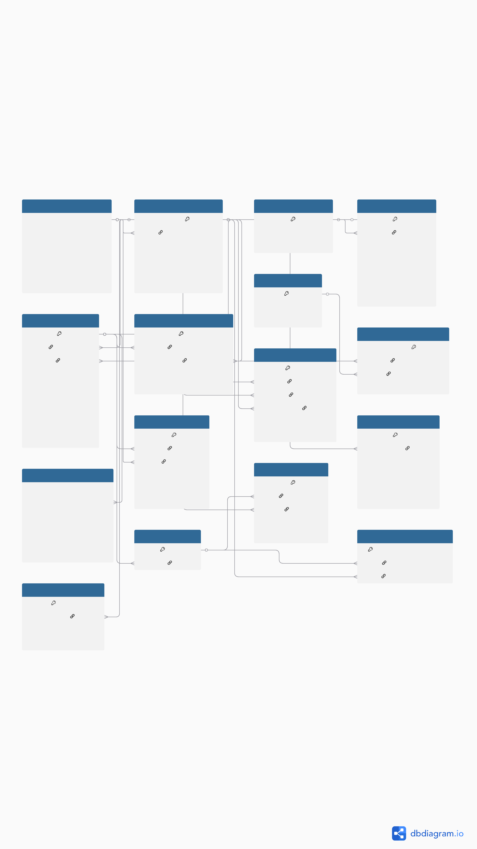

experience_years int

hourly_rate decimal

rating_avg float

BookingAssignment

ServiceCategory |  |  | Package
category_id | int | 0..1 0..1 | package_id | int
name | varchar | * | category_id | int
description | varchar |  | name | varchar
 |  |  | duration_hours | int
AddOn |  |  | edited_photos | int
AddOn |  |  | raw_included | bool
addon_id | _{int} 0..1 |  | raw_included | bool
addon_id | _{int} 0..1 |  | price | decimal
name | varchar |  | price | decimal
price | decimal

booking_id | int | 0..1
client_id | int | *
package_id | int | *

event_date date

start_time time

end_time time

status varchar

total_price decimal

discount decimal

Invoice

invoice_id int

booking_id int

invoice_number varchar

total_amount decimal

discount decimal

paid_status varchar

PortfolioPhoto
photo_id | int
photographer_id | int | *

file_path varchar

caption varchar

assignment_id | int
* booking_id | int
photographer_id | int *

assignment_status varchar

role varchar

 | Payment
 | payment_id | int
* | booking_id | int
* | payer_id | int
 | amount | decimal
 | method | varchar
* | status | varchar

Conversation
conv_id | int | 0..1
* booking_id | int

 | Review
 | review_id | int
* | booking_id | int
* | reviewer_id | int
* | photographer_id | int
 | rating | int
 | comment | varchar

 | Message
 | message_id | int
* | conv_id | int
* | sender_id | int
 | content | text
 | sent_at | datetime

 | Booking_AddOn
 | booking_addon_id | int
* | booking_id | int
* | addon_id | int
 | quantity | int

TimeSlot
timeslot_id | int
* photographer_id | int

date date

start_time time

end_time time

slot_status varchar

 | ConversationParticipant
 | id | int
* | conv_id | int
* | user_id | int

User

user_id int

name varchar

email varchar

phone varchar

password_hash varchar

role varchar

Booking

 | PhotographerProfile
0..1 0..1 | photographer_id | _{int} 0..1
* | user_id | int
 | bio | varchar
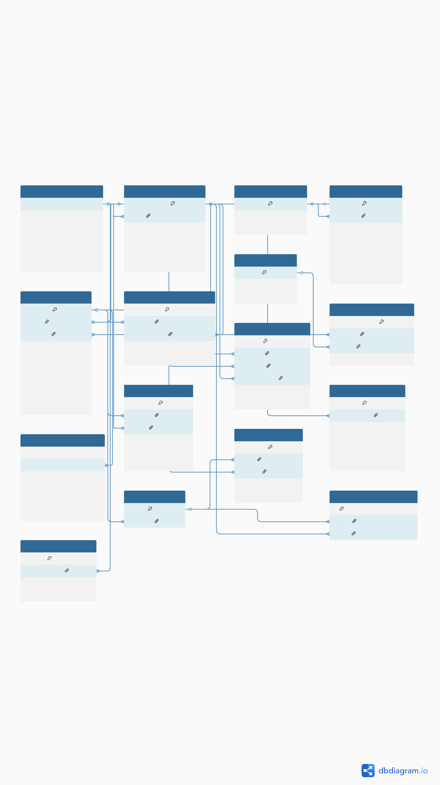

experience_years int

hourly_rate decimal

rating_avg float

BookingAssignment

ServiceCategory |  |  | Package
category_id | int | 0..1 0..1 | package_id | int
name | varchar | * | category_id | int
description | varchar |  | name | varchar
 |  |  | duration_hours | int
AddOn |  |  | edited_photos | int
AddOn |  |  | raw_included | bool
addon_id | _{int} 0..1 |  | raw_included | bool
addon_id | _{int} 0..1 |  | price | decimal
name | varchar |  | price | decimal
price | decimal

booking_id | int | 0..1
client_id | int | *
package_id | int | *

event_date date

start_time time

end_time time

status varchar

total_price decimal

discount decimal

Invoice

invoice_id int

booking_id int

invoice_number varchar

total_amount decimal

discount decimal

paid_status varchar

PortfolioPhoto
photo_id | int
photographer_id | int | *

file_path varchar

caption varchar

assignment_id | int
* booking_id | int
photographer_id | int *

assignment_status varchar

role varchar

 | Payment
 | payment_id | int
* | booking_id | int
* | payer_id | int
 | amount | decimal
 | method | varchar
* | status | varchar

Conversation
conv_id | int | 0..1
* booking_id | int

 | Review
 | review_id | int
* | booking_id | int
* | reviewer_id | int
* | photographer_id | int
 | rating | int
 | comment | varchar

 | Message
 | message_id | int
* | conv_id | int
* | sender_id | int
 | content | text
 | sent_at | datetime

 | Booking_AddOn
 | booking_addon_id | int
* | booking_id | int
* | addon_id | int
 | quantity | int

TimeSlot
timeslot_id | int
* photographer_id | int

date date

start_time time

end_time time

slot_status varchar

 | ConversationParticipant
 | id | int
* | conv_id | int
* | user_id | int

